Table of Contents
Problem 1 2
Part A – Expected Cost Minimization Model 2
Part B – Strategy Swift can use Minimize Cost 3
Part C – EVI for p 4
Part D - Report for Swift Shipping Operations Manager 6
Problem 2 8
Part A – Statistical Forecasting Model 8
Part B – Improved Model using Significant Variables 9
Part C - Consulting Report for Michael 10
Problem 3 12
Part A – Linear Programming Model for Zahret 12
Part B – Pay Per Hour Overtime in Each Department 15
Part C – LP for Optimal Product Quantities 16
Part D - Summary Report for Zahret Company 17
Problem 4 19
Part A – 52 Week Simulation Model 19
Part B – Running Simulation of 500 iterations 20
Part C – Sample Mean and Standard Deviation 20
Part D – Report on Production Policy Analysis for Paxon Pharma 21
References 23

Problem 1

Part A – Expected Cost Minimization Model
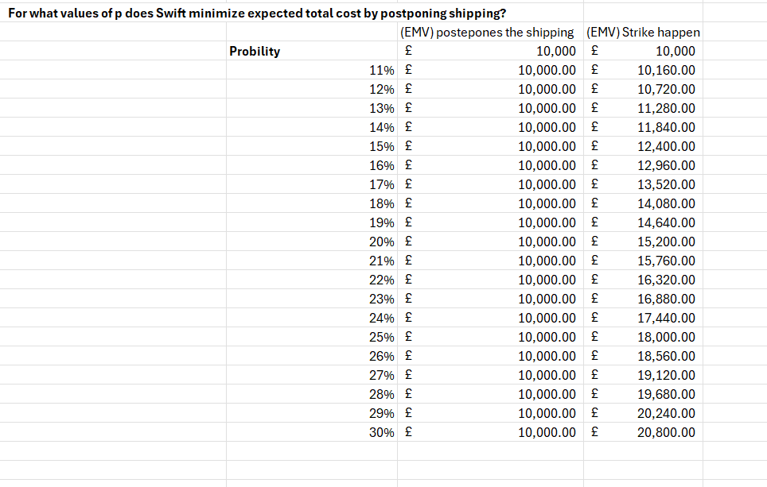

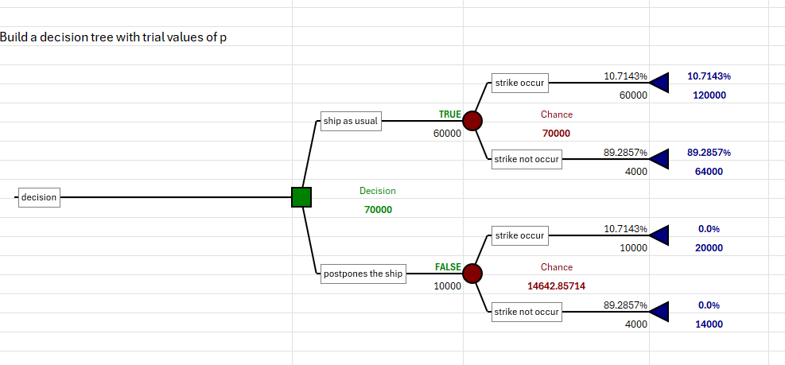

Part B – Strategy Swift can use Minimize Cost
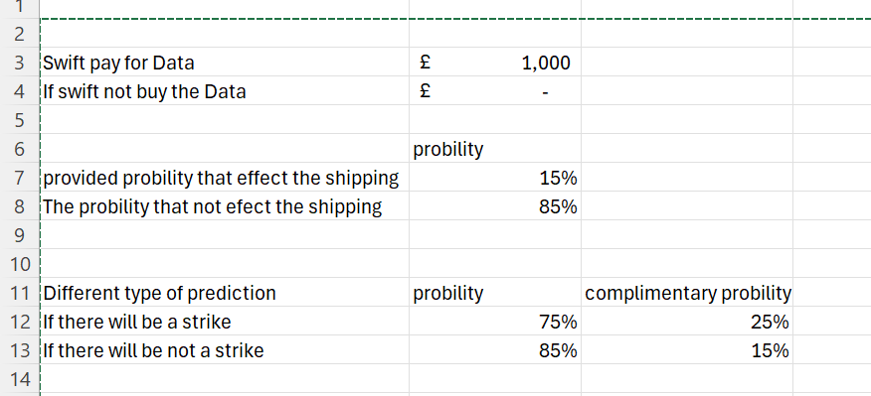
Implementing Bayes' rule
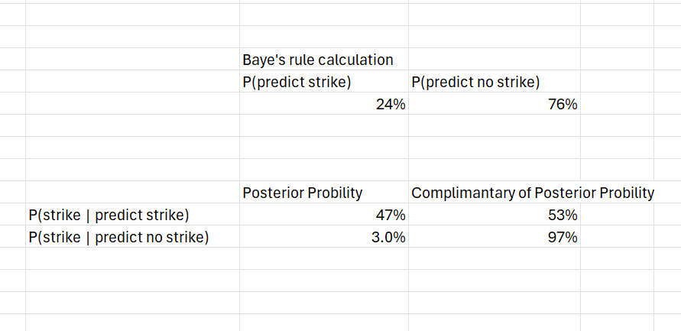
Cost Analysis:

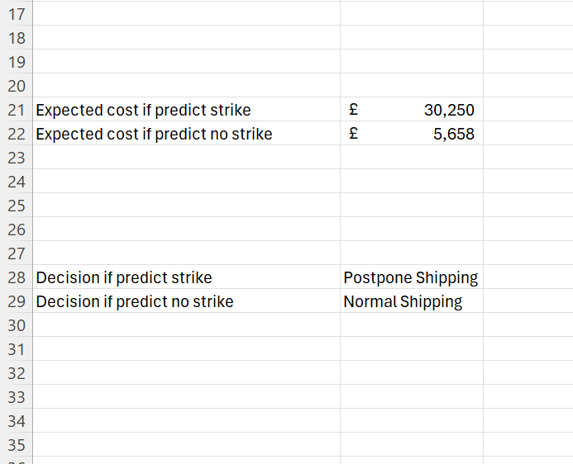

Part C – EVI for p
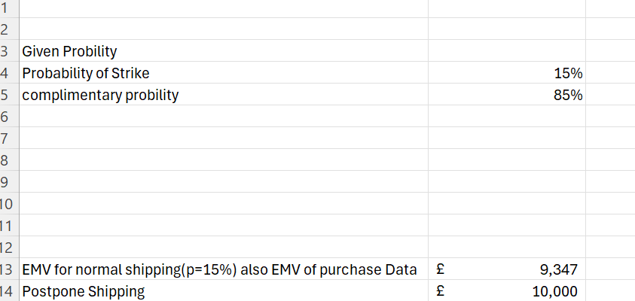

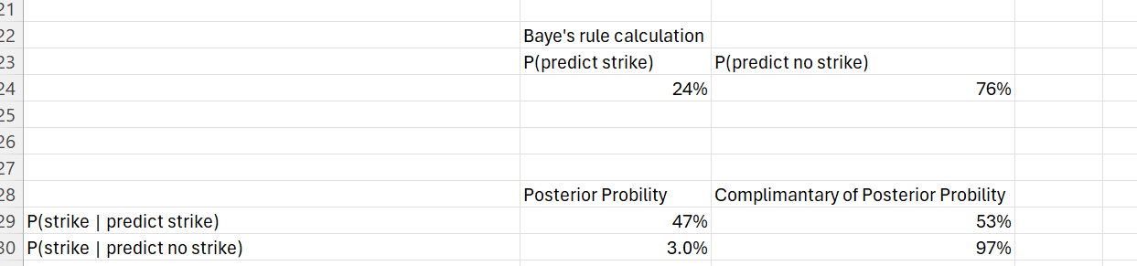
Using bayes’s rule:
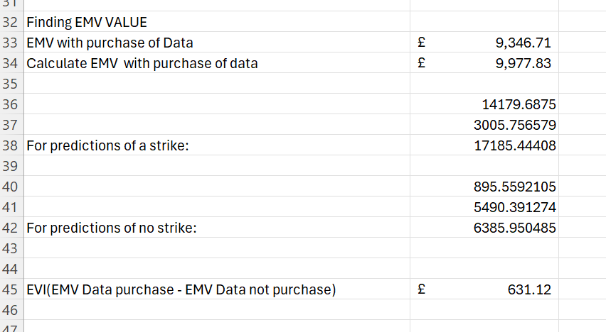

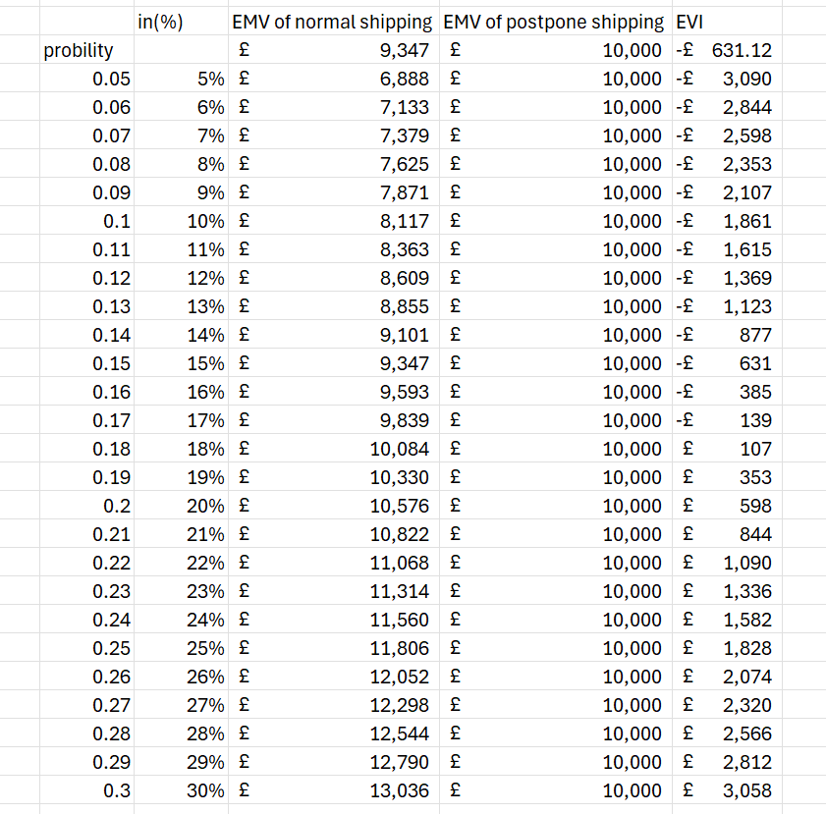
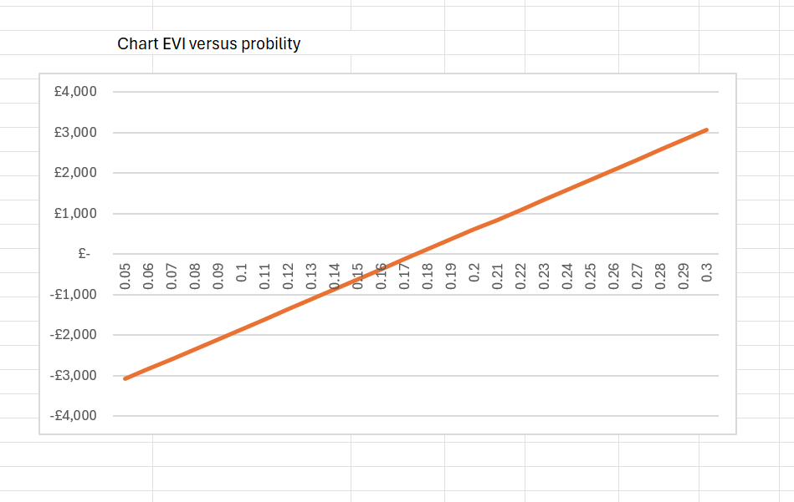

Part D - Report for Swift Shipping Operations Manager
Executive Summary
Considering the prospect of a postal workers' strike in the setting of our company called Swift Shipping, we opted to conduct decision analysis under three scenarios to pinpoint the best strategy. The analysis involved estimation of the Expected Monetary Values (EMVs) as well as the Expected Values of Information (EVIs) for a data-backed guidance (Wang, Rousis and Strbac, 2020).
- Scenario (a): We considered the anticipated costs of shipping with the usual pattern when compared to postponement of shipments with different assumptions of pickets. Our results pointed to the fact that when the strike probability surpassed a particular limit, then it became beneficial to defer the shipments. This target storage cost was determined by calculating the expected cost for both shipping methods.
- Scenario (b): Finally, the forecast was improved by predictive data on the occurrence of strikes. Through integrating with the predicted data of strikes, we observed that postponing the events (if the calculation showed that there was a high possibility of a strike) helped to minimize the potential disruption costs. Contrary to that, the case without strikes can serve as a neutral zone to maintain customer satisfaction and avoid costs that are not essential.
- Scenario (c): We compute the EVI (Extra Value Indicator) to find out the value of a piece extra information for Swift Shipping. The results showed that EVI decreases as the risk of strike raises (the risk of strike increases). This indicates that the predictive data become more valuable when the effect of strike as the probability is not very high because it provides guidance about the most profit strategy.
Recommendations
- When Strike Prediction Indicates High Likelihood: According to the analysis, the company should give a preference to moving its cargo after the wave of strikes if the predictive data indicate a high strike probability. By this kind of strategy, the minimal amount of disruption costs can be anticipated as on the one hand the pre-emptive postponement cost is relatively fixed while on the other rerouting costs can cost massive (Dimitrios Dalaklis et al., 2023).
- When Strike Prediction Indicates Low Likelihood: Swift should go ahead with the original shipment in case the predicted data signify a low chance of a shot. This will aid the business in keeping a good customer experience, its reputation as the top next-day delivery company and also, avoid the unnecessary expenses that come with delay (Samia Zaoui et al., 2023).
Quantitative Support for Recommendations
- Scenario (a) Analysis: The cost analysis revealed that when the probability of a strike was high (above ~.011), the expected cost of shipping normally, which could involve rerouting due to strikes, exceeded the cost of pre-emptive postponement (£10,000). For example, with a strike probability of 0.22, the expected cost of shipping normally is £16,000, making postponing the preferred option.
- Scenario (b) Analysis: Incorporating predictive data, we found that shipping as normal when a strike was predicted would cost Swift £30,250, compared to £10,000 for postponement. This clearly makes postponing the best option in these situations. In contrast, shipping normally in the absence of a predicted strike had an expected cost of £5658, making it the preferable option compared to postponing.
- Scenario (c) Analysis: The EVI analysis highlighted that the value of obtaining perfect information decreases as the probability of a strike increases. For instance, with a strike probability of 0.15, the EVI is significant, emphasizing the value of accurate predictive data with help of bayes’s rule for guiding Swift's strategy. As the strike probability reaches 0.3, the EVI diminishes, suggesting that the benefit of additional information is less impactful (Wu et al., 2021).
Limitations, Risks, and Mitigation Strategies
- Limitations:
  - Data Reliability: The study rests on the presetting of the accuracy of the strike prediction data as it tends to be questionable. Things like job market fluctuations or upheavals in political system can, sometimes in unexpected way, change the possibility of strikes (Weber et al., 2022).
  - Dynamic Scenarios: Strikes can happen without any warning, thus, there is little time for the management to act, and a shipment might not be canceled as early as possible.
- Risks:
  - Customer Trust: A look before you leap approach with scheduling could lead to late deliveries and affect customers' smiles. They might eventually doubt Swift's ability to be punctual with deliveries.
  - Incorrect Decisions: A poor datum predictor will bring a wrong decision, causing unnecessary expenses.
- Mitigation Strategies:
  - Continuous Monitoring: Swift should pay close attention to the labor issues and the reports of industrial news to experience the strikes fast, providing a more correct decision.
  - Effective Communication: Swift should forward these delays sooner than relatively expected. Customers should be creating expectations. The experience should not be letting down.
  - Enhancing Data Quality: Invest in the advanced models of prediction which will include many data sources to ensure the accuracy of predicting strikes.
In short, Swift Shipping must pursue a plan between effectiveness of predictive data and the chance of moving to quickly-changing environment. Through efficient utilization of predictive data and keeping communication lines open, Swift will be able to face the stir ups that might include the closure of the ports as they work on maintaining customer trust.

Problem 2

Part A – Statistical Forecasting Model
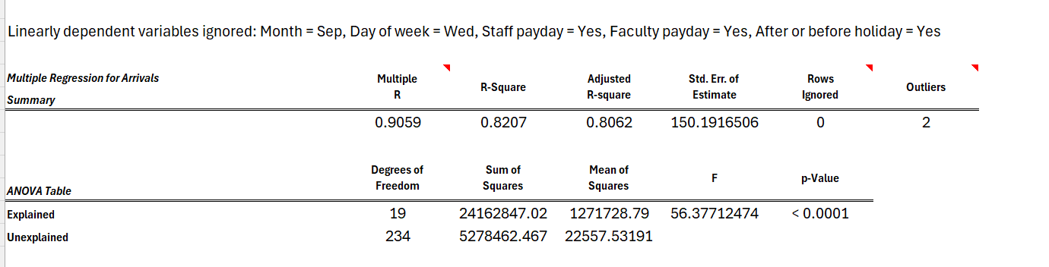

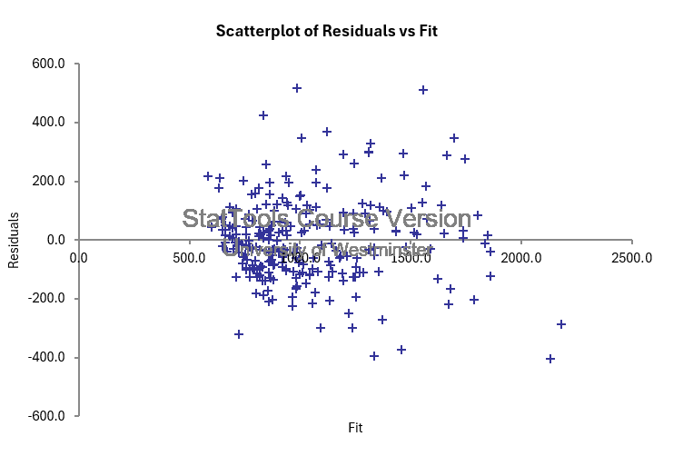

Part B – Improved Model using Significant Variables
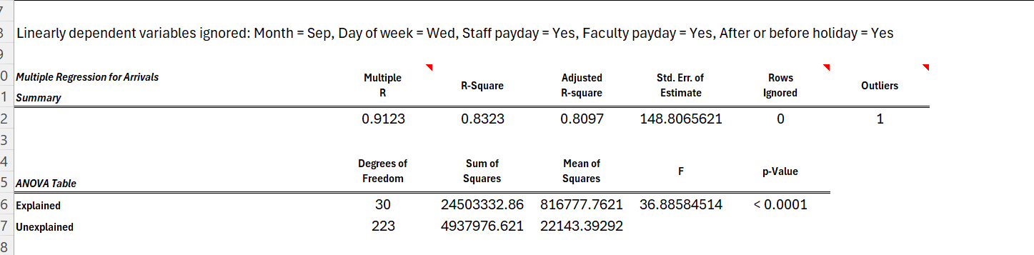
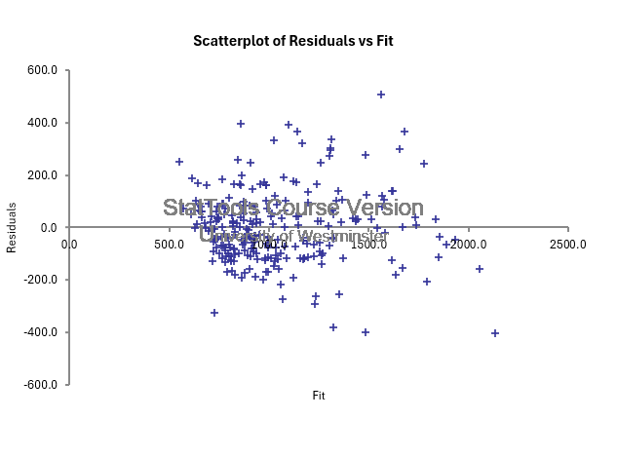

Part C - Consulting Report for Michael
Introduction
The goal of this report is to develop a thorough assessment and prediction model capable of assisting in the superior planning of workforce scheduling at Newcastle University Credit Union branch. The target is to reach employment productivity, control costs, and enhance customer service by adjusting the number of people required to attend to the consumers according to the expected consumer arrivals. An ordinary least squares regression analysis was done and a model with predictors was considered to study the role of these factors on the daily customer footfall. The final model crafted comprised of only the statistically significant variables and few additional factors that affect demand (Hewage et al., 2020).
Final Model Methodology
The final model methodology leverages OLS regression, which establishes a linear relationship between independent variables and customer arrivals. The predictors included (Budak and Sarvari, 2021):
Day of the Week (Dummy Variables): Fridays and Mondays experience considerably greater arrivals (+472.39)and(+257.74),respectively. Staff Payday: A binary variable indicating whether a day was a staff payday.
Staff Payday: -358.91, indicating that there are fewer staff arrivals on non-paydays.
Faculty Payday: -381.93, indicating that there are likewise fewer arrivals on non-faculty paydays.
HolidayPredictive: -270.09, which signifies a decrease in arrivals on days preceding holidays.
.
These variables were carefully selected because they relate directly to observed variations in customer footfall. Data preprocessing involved converting categorical data into dummy variables to include them in the regression model. The model outputs included coefficients and p-values, which guided the selection of significant variables for the final model.
Parameter Estimates and Overall Fit
The final model's parameter estimates, including coefficients and statistical significance, are as follows:
Overall Model Fit:
The obtained Multiple R (Correlation Coefficient) of 0.9123 suggests that the predicted and actual values are strongly correlated along the linear spectrum.
R-Square: 0.8323 indicates that the model accounts for 83.23% of the variance in daily customer arrivals.
Adjusted R-Square: 0.8097, which validates a good fit notwithstanding the complexity of the model, considers the number of predictors.
The standard error of the estimate is 148.81, representing the average deviation of the observed values from the regression line.

Model Assumptions and Validity
The OLS regression model relies on certain assumptions:
- Linearity: The assumption of a linear relationship between the predictors and customer arrivals was visually checked through scatter plots. The observed patterns supported a linear relationship.
- Homoscedasticity: Residuals need to have constant variance. Residual plots showed heteroscedasticity, indicating the variance in residuals changes at different levels of predictions.
Despite some deviations from assumptions, the model remains valuable for predicting customer footfall, with limitations to consider.
Strengths and Limitations
Strengths:
Significant Predictors: The model leverages statistically significant predictors, offering insights into factors influencing daily arrivals.
Limitations:
- Autocorrelation: Positive autocorrelation in residuals suggests that the model isn't capturing some sequential patterns in customer arrivals.
- Heteroscedasticity: The varying variance in residuals suggests predictive accuracy may change across different levels of predicted arrivals.
Conclusion
The model provides valuable insights into customer arrival patterns and predictors. Despite some assumptions not holding perfectly, it remains a useful tool for optimizing staff scheduling based on forecasted arrivals. Incorporating additional predictors and improving model assumptions could further enhance its predictive accuracy.

Problem 3

Part A – Linear Programming Model for Zahret
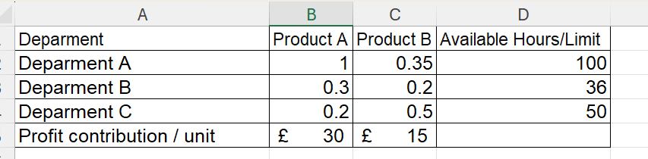

Developing a linear programming model formulation of the Zahret Company problem.

Decision variable:

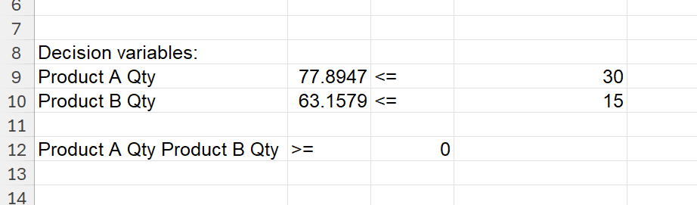
Product A Quantity: The maximum allowable quantity of Product A for production is 30 units.
Product B Quantity: The maximum allowable quantity of Product B for production is 15 units
Constraints:
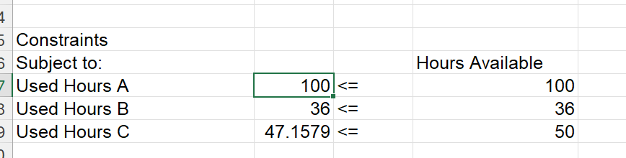
Department A: May allot a maximum of 100 hours, of which 1 hour per unit is allocated to Product A and 0.35 hours per unit is allocated to Product B.
Department B is allocated 36 hours, of which 0.2 hours are utilised per unit for Product B and 0.3 hours are utilised per unit for Product A.
Department C provides 50 hours of labour, of which 0.5 hours per unit are devoted to Product A and 0.2 hours to Product B.

The algebraic formula for constraints is
- 1*x1 + 0.35*x2 <=100
- 0.30*x1 + 0.20*x2 <=36
- 0.20*x1 + 0.50*x2 <=50

Objective Function:
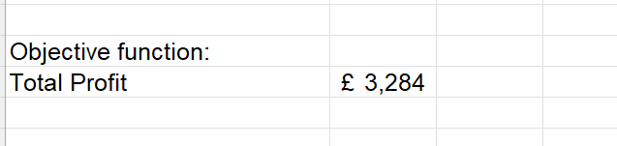
Answer Report
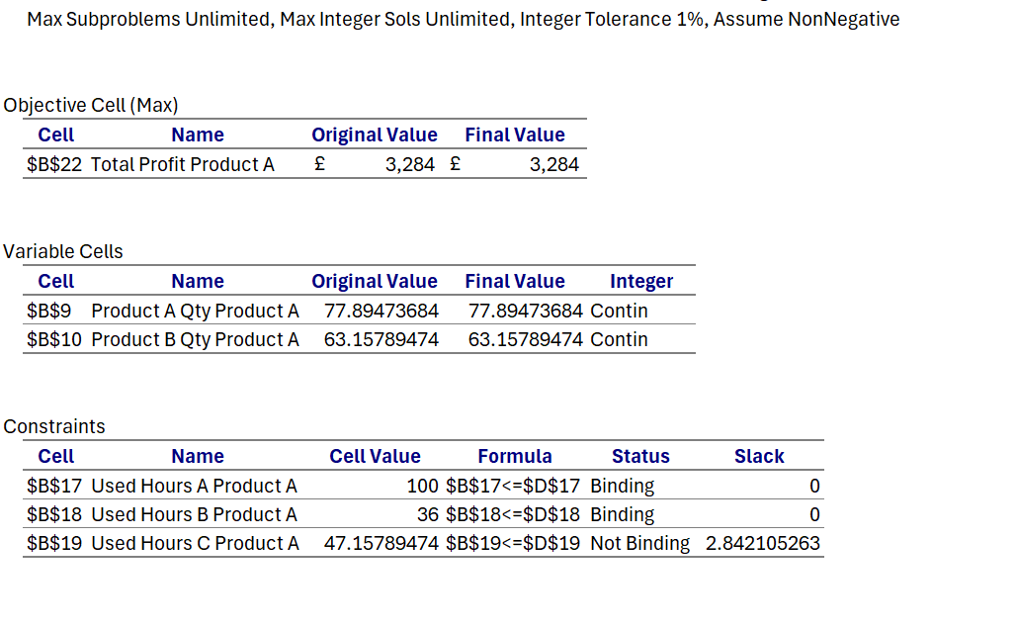

Sensitivity Report:
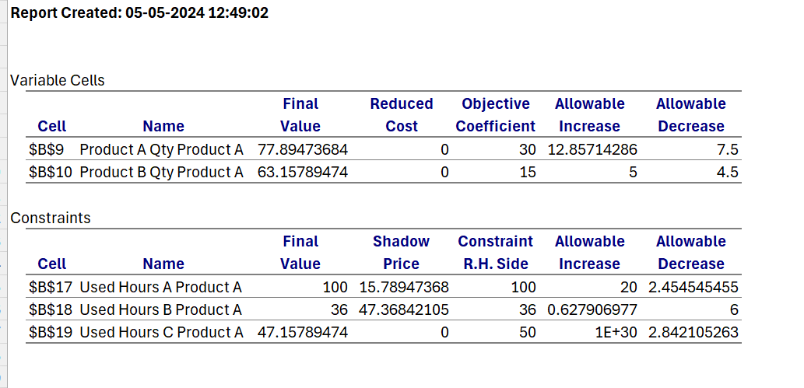

Part B – Pay Per Hour Overtime in Each Department
Answer Report:


Sensitivity Report


Recommendations for Overtime Scheduling:
Department B: Considering the substantial profit contribution of each additional hour of labour, each additional hour of work in Department B is highly valuable at £47.37. The significant value of this indicates a substantial advantage in arranging overtime in this location, despite the relatively modest allowable increase of 0.63 hours. Prioritize the optimization of the allowable overtime increase by the organization.

Department A: The shadow price of £15.79 indicates that adding hours to the department also results in a profitable increase, albeit one that is comparatively less substantial when compared to Department B. Given the department's permissible increase of 20 hours, there is considerable opportunity for the addition of overtime hours.

Department C: The absence of a profit increase from additional hours is indicated by the shadow price of £0. Therefore, it is not advisable to schedule overtime in this department, as it would not result in increased profitability.

How Much to Pay Per Hour of Overtime:
Department B: Payment of overtime wages of approximately £47.37 per hour is justifiable, considering the substantial profit generated with each additional hour, considering the high shadow price. To ensure profitability, practical payment should consider standard wage rates and possibly increase to a level slightly below the shadow price.

Department A: The shadow price indicates that overtime pay could reach £15.79 per hour. Paying less than this hourly rate, considering standard wage rates, would be advisable in order to sustain profitability.

Department C: The reimbursement of overtime wages is not economically rational due to the lack of profit increase resulting from additional hours worked.

Part C – LP for Optimal Product Quantities
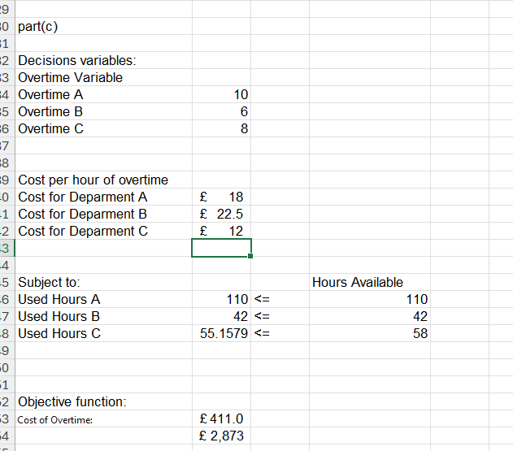
Overtime hours Utilization:
Department A: Extra Hours available: 10 hourly Rate: £18, out of a total of 110 available, are used. Utilized Additional Capacity: 0 hours Despite the availability of overtime, it was not utilized, as indicated by the data provided. This may indicate that despite the availability of additional hours, the hourly rate of £18 does not yield a satisfactory return considering the level of production output or the profit margins associated with the products.

Department B: Extra Hours Provisional: 6 hours hourly Rate: £22.50 Used Hours: 42 (out of a total of 42 hours offered). Utilized Additional Capacity: 0 hours In the same manner as Department A, overtime was not utilized despite its availability. Non-utilization is likely attributable to the higher hourly rate (£22.50), suggesting that the additional expense does not provide sufficient justification for the potential increase in production.

Department C: Extra Hours available: 8 Hourly Rate: £12 Approximately 55.16 (out of 58) hours have been utilized. Additional Capacity: 0 hours Despite having the lowest hourly cost for overtime, Department C did not utilize it. This could be due to a few factors, including adequate production during regular hours or the reduced marginal profit from the additional products manufactured.

Part D - Summary Report for Zahret Company
Problem Overview
Overtime Analysis
To understand the impact of overtime, we considered the additional hours available for each department:
- Department A: 10 hours of overtime at £18/hour
- Department B: 6 hours at £22.50/hour
- Department C: 8 hours at £12/hour
Solution with Overtime
After incorporating the overtime constraints and costs, the optimal solution changes:
Overtime Utilization:
  - Department A: 10 hours
  - Department B: 6 hours
  - Department C: 8 hours

Insights and Recommendations
Department A provides the highest potential for overtime with its higher labor-hour needs, justifying an overtime rate up to £18/hour. Departments B and C can also contribute positively to profitability, but at a lower marginal rate due to their relatively smaller hour demands.
Decision-Making Support
- Maximizing Profit: The analysis emphasizes the importance of maximizing labor utilization, specifically in Department A, due to its significant contribution to profitability.
- Cost Management: While overtime increases production costs, its use is justified by the increase in total profit.
- Production Optimization: The model supports strategic decision-making by pinpointing optimal production quantities and identifying the value of overtime.
By following the model's recommendations, Zahret Company can effectively navigate production constraints, utilize overtime efficiently, and maximize profitability.

Problem 4

Part A – 52 Week Simulation Model
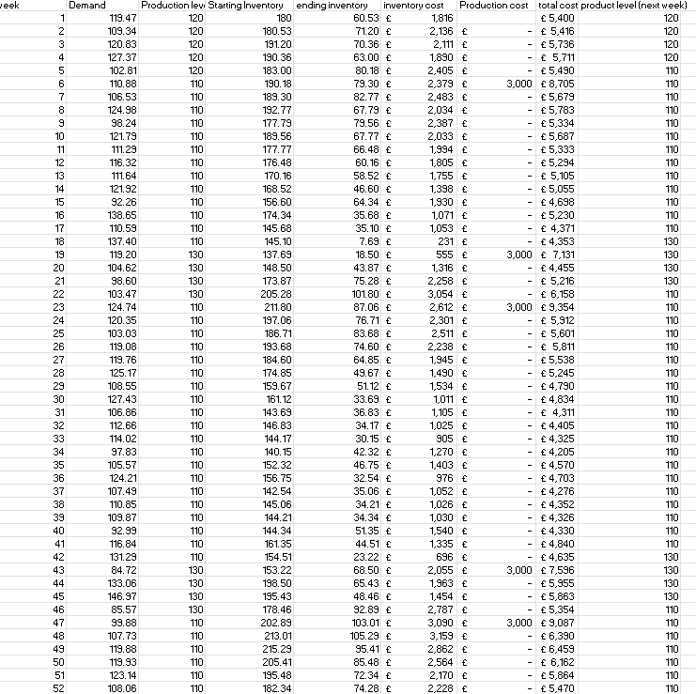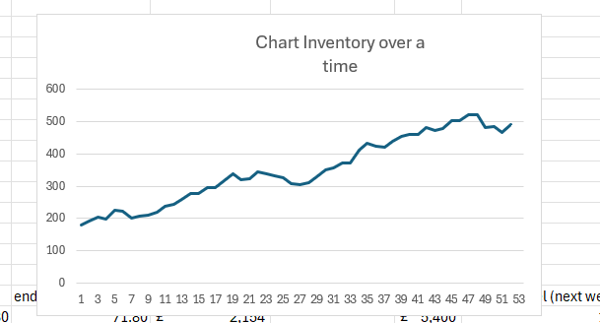

Part B – Running Simulation of 500 iterations
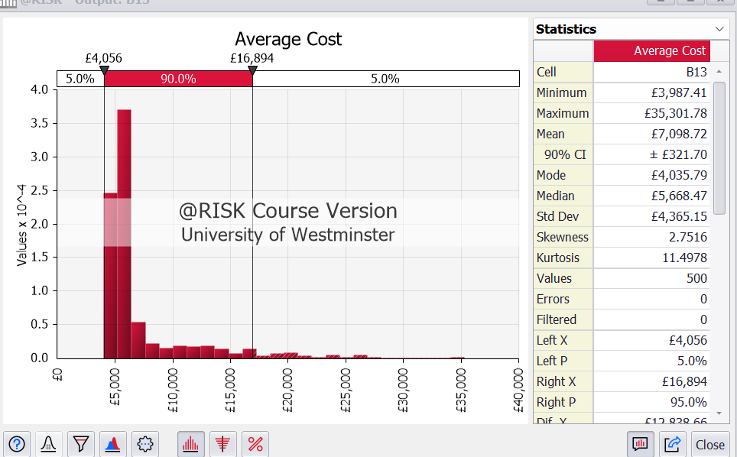

Part C – Sample Mean and Standard Deviation
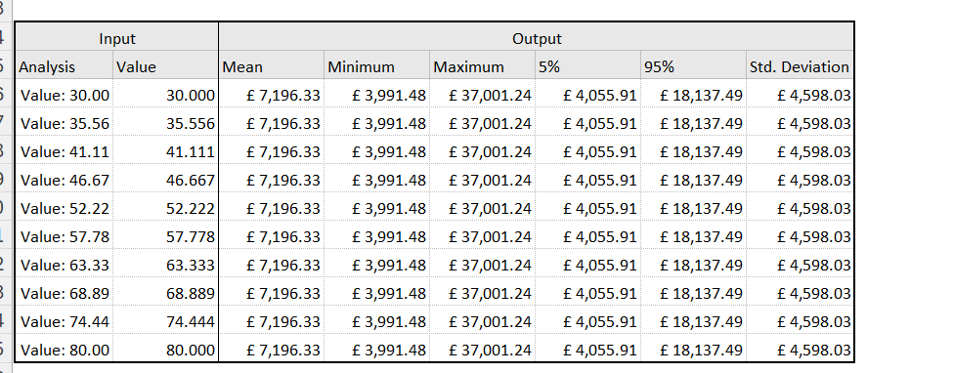

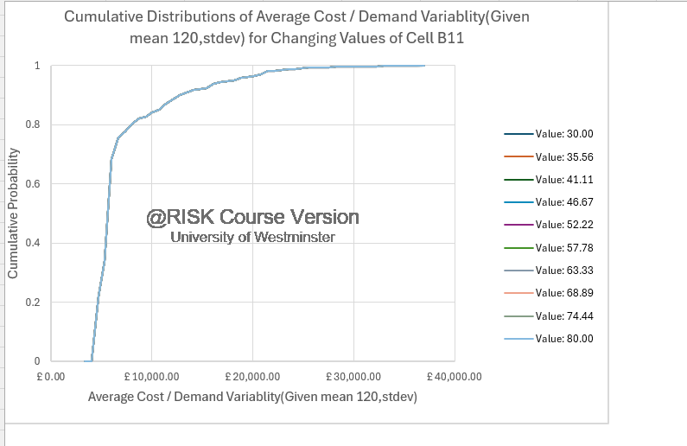
Figure 19 Palisade Tool Chart for the Results

Part D – Report on Production Policy Analysis for Paxon Pharma
Executive Summary:
The goal of this paper is to investigate and rate the production policy of amoxicillin as an antibiotic at Paxon Pharma. The goal is to identify an optimal production planning approach for given 52-week period which leads to a reduction of both inventory and cost of changing products. The analysis demonstrates that the upper the inventory threshold turning out to be the 60 commodities is the most cost effective. This report contains implementation guidelines and a summary of possible larger revisions.
Findings:
- Optimal Threshold Identification:
  - The study dealt with choosing a number of the upper threshold U from 30 to 80 units whereas the lower threshold L was considered constant at 30 units.
The interval (95%) of the cost with U=60 was indeed narrow; this shows that reductions in price were consistent at the said value.
- Cost Analysis:
  - The costs analyzed included both inventories holding costs and changeover costs.
  - Production rates were adjusted based on inventory levels relative to thresholds:
    - Below L, production was set to 130 units.
    - Above U, production was set to 110 units.
    - Otherwise, the production rate remained unchanged from the previous week.
  - The main drivers for cost variability were the production rates and the changeover costs incurred when rates changed.
- Recommendations:
  - Adopt U=60 Policy: Doing so would probably be associated with the lowest cost on average that is determined from the present review.
  - Regularly Review Production Rates: Output rate decision is quite integral for the policy to become even more efficient. It is recommended to review the rates frequently to make sure they are aligned with the changing supply and demand curve.
  - Optimize Inventory Holding Costs: Consider more ways of minimizing the holding costs, for instance by forecasting improvements or getting closer to just-in-time (JIT) inventory management.
  - Monitor Demand Trends: Constant demand surveillance will give the chance the production policy to change according to demand fluctuations.
Strategic Guidance:
- Policy Flexibility:
  - For example, process policies that grant production rates to change in a more dynamic manner based on market changes. The shift to a multi-rate policy would reduce the issue of changeover costs.
- Scenario Planning:
  - Design models which could stimulate demand changes and evaluate how various measures perform in the simulation.
- Technology Integration:
  - Leverage advanced forecasting models which allows for integration with production schedule and improve decision-making.
Further Investigation:
- Demand Forecasting Improvement: Enhanced predictive tools can deliver a more precise indication for future demand, eliminating the risk of overproduction as well as underproduction.
- Advanced Production Planning: Leverage the advantages of Lean production and predictive analytics to re-design the production scheduling process.
- Production Policy Alternatives: Investigate other techniques to make things, for instance, continuous evaluation systems or the use of hybrid models, which may bring more savings.
In summary, the analysis shows us the minimum U value, but the modification of the policy is the matter that is indispensable to keep pace with the changes and remain cost efficient.

References
Afzal, S., Thakur, A. and Singh, P. (2024). Optimization of Cloud Migration Parameters Using Novel Linear Programming Technique. Lecture notes in electrical engineering, pp.43–62. doi:https://doi.org/10.1007/978-981-99-8661-3_4.
Budak, A. and Sarvari, P.A. (2021). Profit margin prediction in sustainable road freight transportation using machine learning. Journal of Cleaner Production, 314, p.127990. doi:https://doi.org/10.1016/j.jclepro.2021.127990.
Dimitrios Dalaklis, Nikitas Nikitakos, Dimitrios Papachristos and Angelos Dalaklis (2023). Opportunities and Challenges in Relation to Big Data Analytics for the Shipping and Port Industries. Studies in National Governance and Emerging Technologies, pp.267–290. doi:https://doi.org/10.1007/978-3-031-25296-9_14.
Hewage, P., Trovati, M., Pereira, E. and Behera, A. (2020). Deep learning-based effective fine-grained weather forecasting model. Pattern Analysis and Applications. doi:https://doi.org/10.1007/s10044-020-00898-1.
Khedr, A.M., Arif, I., P V, P.R., El‐Bannany, M., Alhashmi, S.M. and Sreedharan, M. (2021). Cryptocurrency price prediction using traditional statistical and machine‐learning techniques: A survey. Intelligent Systems in Accounting, Finance and Management, 28(1), pp.3–34. doi:https://doi.org/10.1002/isaf.1488.
Luo, B., Li, X., Wang, S., Huang, J. and Leandros Tassiulas (2021). Cost-Effective Federated Learning Design. arXiv (Cornell University). doi:https://doi.org/10.1109/infocom42981.2021.9488679.
Samia Zaoui, Clovis Foguem, Dieudonné Tchuente, Samuel Fosso Wamba and Kamsu-Foguem, B. (2023). The Viability of Supply Chains with Interpretable Learning Systems: The Case of COVID-19 Vaccine Deliveries. Global Journal of Flexible Systems Management, 24(4), pp.633–657. doi:https://doi.org/10.1007/s40171-023-00357-w.
Tyler, N.S., Mosquera-Lopez, C.M., Wilson, L.M., Dodier, R.H., Branigan, D.L., Gabo, V.B., Guillot, F.H., Hilts, W.W., El Youssef, J., Castle, J.R. and Jacobs, P.G. (2020). An artificial intelligence decision support system for the management of type 1 diabetes. Nature Metabolism, 2(7), pp.612–619. doi:https://doi.org/10.1038/s42255-020-0212-y.
Wang, Y., Rousis, A.O. and Strbac, G. (2020). On microgrids and resilience: A comprehensive review on modeling and operational strategies. Renewable and Sustainable Energy Reviews, [online] 134, p.110313. doi:https://doi.org/10.1016/j.rser.2020.110313.
Weber, S., Heim, S., Richiardi, J., De, V., Tereza Serranová, Jech, R., Marapin, R.S., Marina AJ Tijssen and Aybek, S. (2022). Multi-centre classification of functional neurological disorders based on resting-state functional connectivity. NeuroImage. Clinical, 35, pp.103090–103090. doi:https://doi.org/10.1016/j.nicl.2022.103090.
Wu, J., Bai, Y., Zhao, H., Hu, X. and Cozzani, V. (2021). A quantitative LNG risk assessment model based on integrated Bayesian-Catastrophe-EPE method. Safety Science, 137, p.105184. doi:https://doi.org/10.1016/j.ssci.2021.105184.

